Practical Number | 01
Areas covered | Memory concepts, Data Input & output ,primitive data types

Write a C program for each of the following question
- Display your name and school name in two separate lines
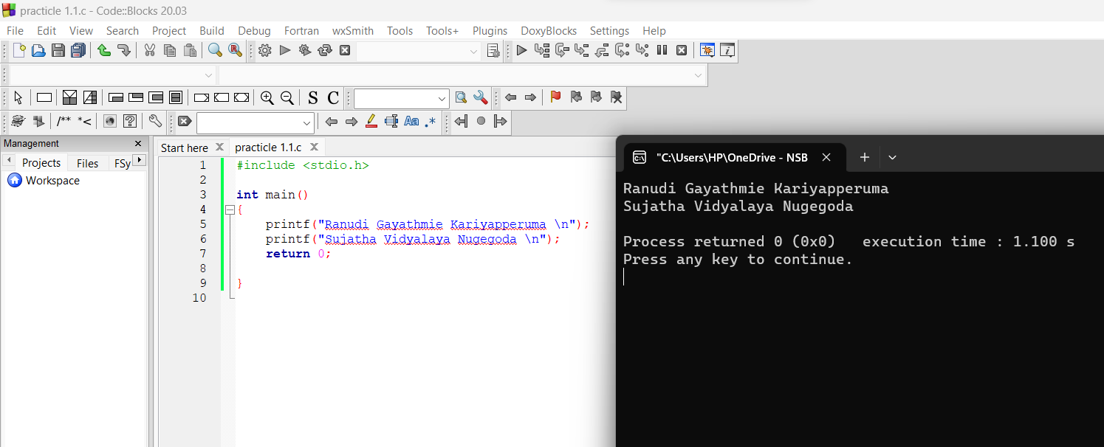

- Display the following output using printf() statements
*
**
***
****
*****
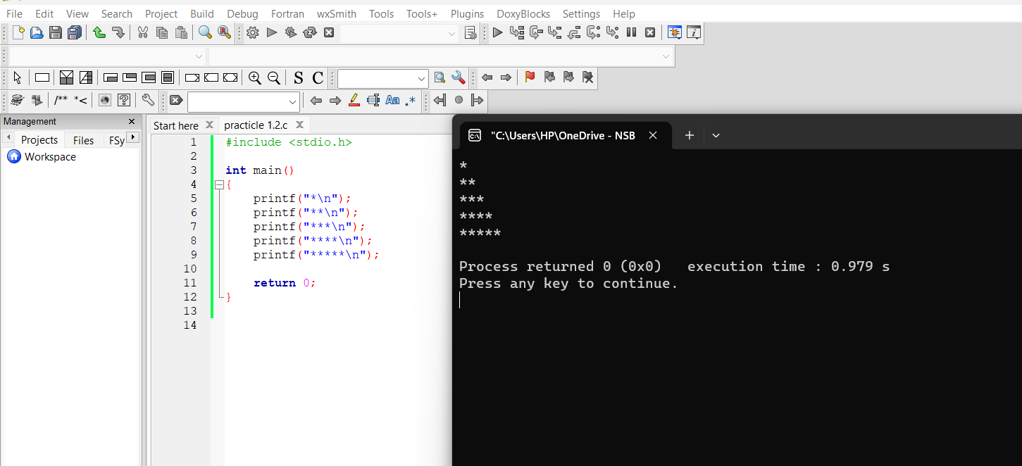

- Input values for int,float,double and char data types and display the value of each of the variable.

- Input two integers and display the total

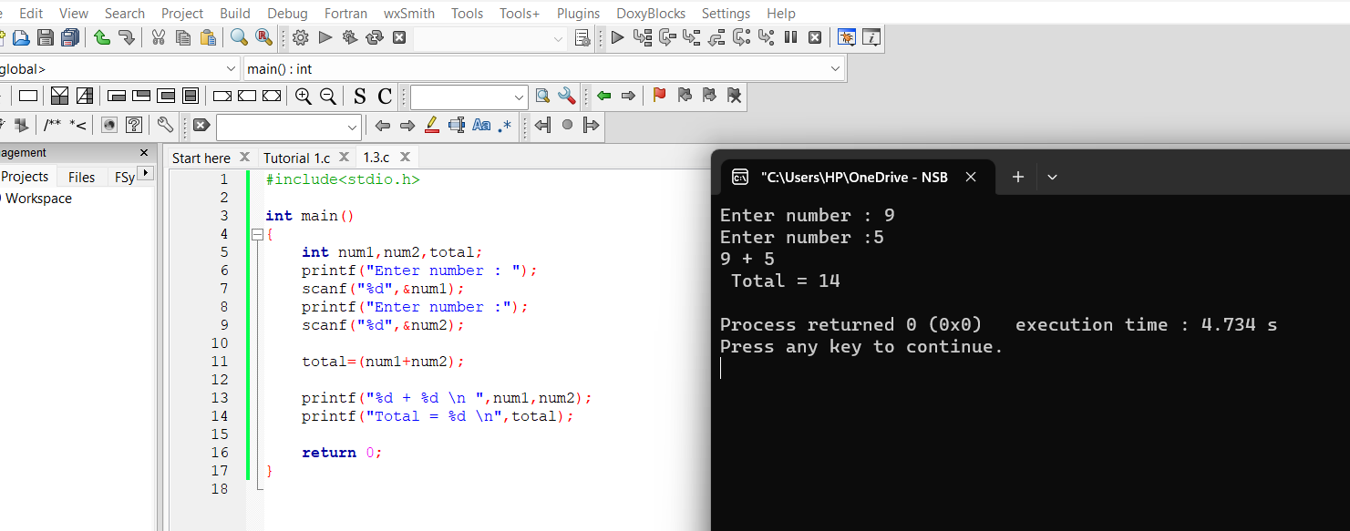

- Input two numbers with decimals(fractions) and display the average with decimals
- Input a student name, birth year and display student name with age.
- Input two numbers, swap the values and display the output. ( Before swap and after swap)
- Execute the following code and analyze the output. Study the output format.
#include<stdio.h>
main()
{
printf("The color: %s\n", "blue");
printf("First number: %d\n", 12345);
printf("Second number: %04d\n", 25);
printf("Third number: %i\n", 1234);
printf("Float number: %3.2f\n", 3.14159);
printf("Hexadecimal: %x\n", 255);
printf("Octal: %o\n", 255);
printf("Unsigned value: %u\n", 150);
printf("Just print the percentage sign %%\n", 10);
}

